**CHAPTER-1**

## I**NTRODUCTION**

The **Night Vision Spy bot Project** is an innovative concept that focuses on creating a robotic system capable of operating in low-light or complete darkness conditions using night vision technology. The goal is to design a robot with enhanced surveillance capabilities, making it suitable for applications in security, military operations, search and rescue, and surveillance tasks in challenging lighting environments.

**Key Components of the Project:**

**1. Night Vision Technology:**

* The core of the project is to incorporate infrared (IR) or thermal imaging cameras that allow the robot to see in the dark by detecting heat signatures or using near-infrared light.
* These technologies are vital for the bot to navigate and detect objects or people even in pitch-black conditions.

**2. Robotic Mobility:**

* The robot needs to be equipped with sensors (like ultrasonic or Li-DAR) for obstacle detection, and actuators (wheels, legs, or tracks) to move smoothly in complex environments.
* Autonomous navigation and movement control are often incorporated using AI algorithms to allow the robot to perform its tasks without human intervention.

**3. Surveillance and Reconnaissance:**

* The spy bot is designed to covertly collect information and send real-time data to a control centre or operator. This could include live video feeds, thermal images, or other sensor data.
* The robot might be equipped with microphones and cameras to eavesdrop or observe without being detected.

Night vision-equipped spy bots are designed to monitor areas in complete darkness or low-light conditions. These bots typically use infrared (IR) or thermal imaging technology to capture visual information at night.

Infrared Night Vision: This system uses infrared light to illuminate an area and capture images based on the heat emitted by objects. Spy bots can use this to "see" in total darkness, identifying heat signatures from people, vehicles, or equipment.

Thermal Imaging: Unlike traditional night vision, which amplifies ambient light, thermal cameras detect the heat emitted by objects. This technology allows the spy bot to distinguish between living beings and other heat sources, making it useful for detecting hidden individuals or animals in dark environments.

The surveillance spy bot, equipped with night vision, can silently monitor activities, detect movements, and record visual data in areas where human presence is impossible or undesirable.

Reconnaissance with Night Vision Spy Bots For reconnaissance missions, night vision spy bots are deployed to gather specific intelligence about the environment or enemy activities during nighttime or low visibility conditions.

Detailed Area Scanning: These bots can be sent to scout hostile or unfamiliar areas, such as enemy territory or a specific target location. Using night vision, they can gather crucial information like troop movements, enemy fortifications, or terrain features, even when there's no natural light.

## **CHAPTER-2**

## **LITERATURE REVIEW**

* The concept of a N**ight vision spy bot** intersects various fields such as robotics, computer vision, infrared technology, autonomous systems, and surveillance applications. The integration of N**ight vision technology** into robotic platforms to facilitate covert and efficient operations in low-light conditions has been the subject of several research studies, technological developments, and practical implementations.
* This literature review synthesizes existing research and developments in these areas to provide a foundational understanding of **Night vision spy bot** technologies, challenges, and advancements.
* **Spy bots**: Spy bots are small, autonomous robots designed for surveillance or espionage. These robots can gather intelligence, monitor areas, or even gather data from enemy zones without being detected. They can be equipped with cameras, microphones, or sensors to relay information back to their operators. These bots can be mobile or stationary, depending on their mission.
* **Integration of Night Vision in Spy bots**: Researchers have focused on integrating night vision technology into spy bots to improve their effectiveness during covert operations at night. This integration helps bots navigate in complete darkness, enabling them to gather crucial information or monitor enemies without revealing their presence. Many modern spy bots are equipped with both infrared cameras and night vision lenses.
* **Recent Developments in Spybot Night Vision Project:** Numerous research projects and commercial products have aimed to combine night vision technology with autonomous robotic platforms for surveillance. A few notable developments include
* **Night Vision Surveillance Robots in Military Applications**: The military has made significant progress in integrating night vision into robotic platforms, with an emphasis on remote reconnaissance in hostile environments.
* **Civilian Surveillance Robots**: Law enforcement agencies and private security companies are also exploring the use of night vision-equipped robots for public safety and property surveillance.\
* Letian et al. have discussed about a robot which performs the image processing through the camera mounted on the top.
* Sri et al. have presented a surveillance robot for home security.
* Muhammad Hamza, M Antique-Ur-Rehman, Hamza Shafqat, Subhan Bin Khalid [2019] proposed an idea about a platform to remotely control a surveillance robot over the internet. It will enable us to monitor the activities in the remote and sensitive areas. In traditional security systems, fixed locations are used for monitoring and spying purposes. For such cases, our robotic system is mobile and it can go into those areas where human access is risky, impossible or not suitable and provide us with the footage of those locations. The camera mounted on the robot keeps on capturing the video. This live video from the robot will be streamed on the webpage and it will be used for both surveillance and controlling the robot movement accordingly. The movement algorithm of the robot is implemented using CGI scripts and the monitoring is done by utilizing the MJPG video streamer. The aim is to control the robot from anywhere in the world via webpage and to make thedelay time as little as possible.

**CHAPTER-3**

**EXISTING SYSTEM AND PROPOSED SYSTEM**

**3.1 EXISTING SYSTEM**

Existing System The main usage of this spy bot is to capture images and videos of inaccessible places and should transmit them to a receiver which can be a computer or a TV unit. Here the 8051 microcontrollers will be used as the microcontroller and act as the brain of system

**3.2 PROPOSED SYSTEM**

The proposed Night Vision Spy bot system is a versatile and highly capable robot that can perform a range of tasks related to detecting and neutralizing threats in military and other hazardous environments. The system will be controlled using a Wi-Fi based control system, which will allow for remote operation of the robot from a safe distance. The system allows the user to remotely control the robot various functions, making it suitable for use in hazardous environments where human operators may be at risk.

**CHAPTER-4**

**BLOCK DIAGRAM AND WORKING PRINCIPLE**

**4.1 BLOCK DIAGRAM OF NIGHT VISION SPYBOT**



**CAMERA**

**BATTERY**

**WIFI**

**ESP32MC**

**MOTOR**

**DRIVER**

**(L298N)**

**MOBILE/PC**

Figure 4.1: Block diagram of Night vision spybot

**WORKING:**

**1.Night Vision Technology**

* **Infrared (IR) Sensors:** The bot uses infrared sensors to detect heat emitted by objects. These sensors can pick up infrared light, which is invisible to the human eye but can reveal the heat signatures of living beings, machines, or other objects. The bot then uses this data to create a visual representation of the surroundings, even in complete darkness.
* **Near-Infrared (NIR) Light:** Some Night vision systems emit a low level of near-infrared light that’s invisible to humans but detectable by the bot’ cameras. This allows the bot to "illuminate" its environment for better vision in total darkness.

2. **Camera and Imaging System**

* The bot is typically equipped with specialized cameras that capture visual data either in the infrared or visible spectrum, depending on its design.
* **Low-Light or Thermal Imaging:** Depending on the system, the bot might use thermal imaging cameras to see heat signatures or low-light cameras to capture images with minimal ambient light.

3. **Processing and Visualization**

* The captured images or data are then processed by the bot’s onboard computer. The system converts infrared or thermal data into a visual representation that the bot can use to navigate or detect objects, humans, or other points of interest.
* For thermal vision, the display shows objects in different colours based on temperature, with warmer areas appearing brighter or in different colours than cooler ones.

4. **Autonomous Movement and Control**

* **Sensors:** Apart from cameras, Night vision spy bots also often incorporate additional sensors (such as ultrasonic or LIDAR) for navigation in the dark, avoiding obstacles, and following predetermined paths.
* **AI or Pre-programmed Behaviour:** Many bots rely on AI algorithms to make decisions based on the data received from their sensors. This could involve recognizing human movement, detecting heat sources, or avoiding obstacles
* **Movement and Navigation:** The bot must be able to move through different environments, often in the dark avoid obstacles. The movement of the bot is controlled by its **motors** and **actuators**:
* **Motors**: These are responsible for the physical movement of the bot (wheeled, tracked, or legged). The motors are controlled by the robot’s onboard **microcontroller** (often an **Arduino**, **Raspberry Pi**, or other similar controller).
* **Sensors for Obstacle Avoidance**: To navigate effectively in the dark, the robot is equipped with sensors like **ultrasonic sensors**, **infrared proximity sensors**, or **LiDAR**. These sensors detect obstacles in the robot’s path and send signals to the controller, which then adjusts the movement to avoid collision.
* **GPS**: Some advanced night vision spy bots also use **GPS modules** to track their location. This is especially useful for larger-scale operations or when the bot is deployed over a wide area.
* **Autonomous Navigation (Optional)**: If the bot is designed for autonomous navigation, it uses algorithms such as **pathfinding** (e.g., A* or Dijkstra) to determine the best route through its environment based on the information from its sensors.
* **Data Processing and Control:** The bot needs to process the data from the night vision camera and make decisions about how to move or respond. This is done through an onboard **microcontroller** or **processor**.
* **Camera Data Processing**: The images or video captured by the night vision camera is processed in real time by the bot’s controller. For example, the video feed may be sent through **image processing software** (such as **OpenCV**) to detect motion, identify objects, or enhance the image quality.
* **Control Algorithms**: If the bot is autonomous, it uses algorithms for decision-making, such as navigation algorithms (to avoid obstacles), path-planning, and object recognition (to identify specific targets or areas of interest).
* **Communication System**: The bot typically sends processed data back to its operator using a wireless communication system. This could be **Wi-Fi**, **Bluetooth**, or **cellular networks** for remote monitoring and control.

**5. Wireless Communication and Data Transmission:**

To allow an operator to remotely control or monitor the bot, a **wireless communication system** is essential. The bot can send real-time video feeds, environmental data, and positional information to the operator. Here’s how it works:

* **Real-Time Video Feed**: The night vision camera streams live video (or captures still images) to the operator. This could be transmitted through **Wi-Fi** or **cellular networks** to a smartphone, tablet, or computer.
* **Command and Control**: The operator can control the bot’s movements (e.g., move forward, turn, stop) via a remote interface, which could be a **mobile app** or **web-based GUI**. The bot’s sensors send data (e.g., obstacle detection or GPS coordinates) back to the operator in real time, allowing for better decision-making.
* To allow an operator to remotely control or monitor the bot, a **wireless communication system** is essential. The bot can send real-time video feeds, environmental data, and positional information to the operator. Here’s how it works:

**6. Power Supply:**

The **power system** is crucial for the bot’s operation, especially since night vision cameras and motors consume a significant amount of energy. Typically, the bot is powered by **rechargeable batteries** that supply power to all its components.

* **Battery**: The most common power source is a **lithium-ion (Li-ion)** or **lithium-polymer (LiPo)** battery. These provide a high energy density, meaning the bot can operate for hours without needing a recharge.
* **Power Management**: To maximize the bot’s uptime, there are power management systems that efficiently distribute energy to different parts of the robot. This can include power-saving algorithms and low-power modes for non-essential systems when the bot isn’t moving or processing heavy data.

**7. Security Measures:**

For sensitive operations, such as military or law enforcement missions, **data security** is critical. The bot can be equipped with encryption for communication and image data to prevent unauthorized access or hacking.

* **Encrypted Communication**: The video feeds and control signals sent between the bot and the operator can be encrypted to ensure that only authorized users can access the information

The "working" of a night vision spybot involves a combination of electronic, mechanical, and software systems. Here's a general overview of how these systems interact:

1**. Core Components and Their Functions**:

* **Power Supply:** 
  + A battery provides the necessary power for all the bot's components.
  + Power management circuitry ensures stable voltage and prevents damage from overcharging or discharging.
* **Microcontroller:** 
  + This is the "brain" of the bot. It receives commands from the remote control, processes sensor data, and controls the motors and other actuators.
  + It runs software that dictates the bot's behaviour.
* **Mobility System:** 
  + Motors drive the wheels or tracks, enabling the bot to move.
  + Encoders (if present) provide feedback on the motor's speed and position, allowing for precise control.
* **Night Vision System**:
  + An infrared (IR) camera captures images in low-light or dark conditions.
  + IR illuminators emit infrared light, which is invisible to the human eye but can be detected by the IR camera.
  + The camera's output is then processed and transmitted as a video feed.
* **Sensors:** 
  + Motion sensors (PIR) detect movement.
  + Other sensors (temperature, humidity, etc.) provide additional environmental data.
  + Sensor data is sent to the microcontroller for processing.
* **Communication System:** 
  + A wireless module (Wi-Fi, Bluetooth, RF) transmits and receives data between the bot and the remote-control device.
  + This allows for remote control of the bot and transmission of video, audio, and sensor data.
* **Remote Control:** 
  + A smartphone, tablet, or computer with a dedicated app or software interface is used to control the bot.
  + The user can view live video, control movement, and access sensor data.

**2. Operational Flow:**

* **Command Input:** 
  + The user sends commands to the bot through the remote-control interface.
* **Signal Transmission**:
  + The commands are transmitted wirelessly to the bot's communication module.
* **Microcontroller Processing**:
  + The microcontroller receives the commands and interprets them.
  + It then sends signals to the motors to control the bot's movement.
  + It also manages the operation of the camera, sensors, and other components.
* **Data Acquisition:** 
  + The night vision camera captures video, and the sensors collect data.
* **Data Transmission**:
  + The video and sensor data are transmitted wirelessly to the remote-control device.
* **Data Display:** 
  + The user views the live video and sensor data on the remote-control interface.

**In essence:**

* The user provides input.
* The bot executes those instructions, gathering visual and sensory information.
* That information is then relayed back to the user.

Therefore, the night vision spybot is a collection of systems that when working in conjunction, allow for remote viewing and operation in low light conditions.

**CHAPTER-5**

**COMPONENTS**

**5.1 HARDWARE COMPONENTS**

1. ESP32 Camera   
2. WIFI-module ESP8266

3. Motor driver   
4. DC motor

5. Power supply

**5.1.1 ESP32 CAMERA**

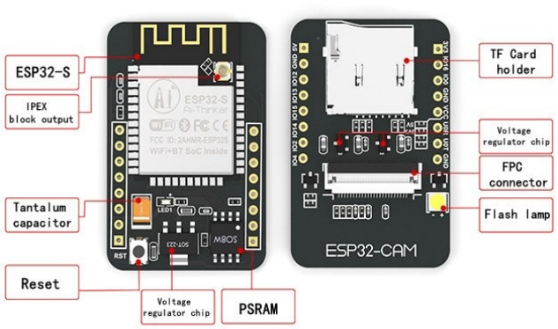

Figure 5.1.1: ESP32 camera

The **ESP32 Camera** is a development board based on the **ESP32** microcontroller, integrated with a **camera module** to capture images or video. It's a popular choice for Internet of Things (IoT) projects, home security systems, and DIY surveillance cameras because it is affordable, compact, and versatile.

1.**ESP32 Microcontroller:**

* + **Dual-core Processor:** The ESP32 has a **dual-core** CPU running at a maximum of **240 MHz**, providing substantial processing power for a variety of tasks.
  + **Wi-Fi & Bluetooth:** It has built-in **Wi-Fi** and **Bluetooth** capabilities, allowing the ESP32 Camera to connect to networks and other devices for communication.
  + **Memory:** Typically, the ESP32 comes with **4MB of flash memory** and **520 KB of RAM**.

**2.Camera Module:**

* + The camera module is usually an **OV2640** or **OV7670** camera, offering a resolution of **2MP** (1600x1200 pixels). However, the exact resolution can vary depending on the camera model used.
  + It typically supports image compression formats such as **JPEG**, making it easy to transmit images or video over Wi-Fi.

**2.Connectivity:**

* + **Wi-Fi**: The ESP32 Camera connects to a Wi-Fi network, enabling it to stream images or video to an app, a cloud service, or a remote server.
  + **Bluetooth**: Bluetooth is also supported for direct communication with devices like smartphones or other ESP32 devices.
  + It can also be used in applications like motion detection, face recognition, or connected surveillance.

**3.Power Supply:**

* + The ESP32 Camera typically runs on **3.3V** and can be powered using a **USB cable** or a **battery** for portable applications.
  + Some models support **low-power modes**, making it suitable for battery-powered or solar-powered applications.

**5.1.2 Wi-Fi Module - ESP8266:**

**Description:**

The ESP8266 Wi-Fi Module is a self-contained SOC with integrated TCP/IP protocol stack that can give any microcontroller access to your Wi-Fi network. The ESP8266 is capable of either hosting an application or offloading all Wi-Fi networking functions from another application processor. Each ESP8266 module comes pre-programmed with an AT command set firmware, meaning, you can simply hook this up to your Arduino device and get about as much Wi-Fi-ability as a Wi-Fi Shield offers (and that’s just out of the box)! The ESP8266 module is an extremely cost-effective board with a huge, and ever growing, community.

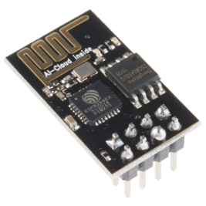

Figure 5.1.2: ESP8266 Wi-Fi Module

This module has a powerful enough on-board processing and storage capability that allows it to be integrated with the sensors and other application specific devices through its GPIOs with minimal development up-front and minimal loading during runtime. Its high degree of on-chip integration allows for minimal external circuitry, including the front-end module, is designed to occupy minimal PCB area. The ESP8266 supports APSD for VoIP applications and Bluetooth co-existence interfaces, it contains a self-calibrated RF allowing it to work under all operation conditions, and requires no external RF parts.

There is an almost limitless fountain of information available for the ESP8266, all of which has been provided by amazing community support. In the *Documents* section below you will find many resources to aid you in using the ESP8266, even instructions on how to transforming this module into an IoT (Internet of Things) solution!

**Note:** The ESP8266 Module is not capable of 5-3V logic shifting and will require an external [Logic Level Converter](https://www.sparkfun.com/products/12009). Please do not power it directly from your 5V dev board.

**Note:** This new version of the ESP8266 Wi-Fi Module has increased the flash disk size from 512k to 1MB.

**Features:**

* .11 b/g/n
* 802Wi-Fi Direct (P2P), soft-AP
* Integrated TCP/IP protocol stack
* Integrated TR switch, balun, LNA, power amplifier and matching network
* Integrated PLLs, regulators, DCXO and power management units
* +19.5dBm output power in 802.11b mode
* Power down leakage current of <10uA
* 1MB Flash Memory
* Integrated low power 32-bit CPU could be used as application processor
* SDIO 1.1 / 2.0, SPI, UART
* STBC, 1×1 MIMO, 2×1 MIMO
* A-MPDU & A-MSDU aggregation & 0.4ms guard interval
* Wake up and transmit packets in < 2ms
* Standby power consumption of < 1.0mW (DTIM3)

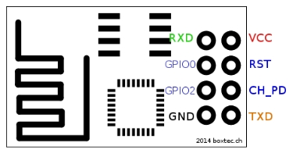

Fig.5.1.2.1: Wi-Fi Module Pinout

The hardware connections required to connect to the ESP8266 module are fairly straight-forward but there are a couple of important items to note related to power:

* The ESP8266 requires 3.3V power–do not power it with 5 volts!
* The ESP8266 needs to communicate via serial at 3.3V and does not have 5V tolerant inputs, so you need level conversion to communicate with a 5V microcontroller like most Arduinos use.

However, if you’re adventurous and have no fear you can possibly get away with ignoring the second requirement. But nobody takes any responsibility for what happens if you do. :) Here are the connections available on the ESP8266 Wi-Fi module.

**5.1.3 MOTOR DRIVERS**

In a hand gesture robot controller using Arduino, motor drivers are crucial components that facilitate the movement of the robot's motors based on the input signals received from the Arduino board. These drivers act as intermediaries between the Arduino and the motors, providing the necessary power and control signals to drive the motors according to the hand gestures detected by sensors or input devices. Depending on the type of motors used (DC motors, stepper motors, etc.), different motor drivers may be employed, such asL298N, L293D, or specialized stepper motor drivers.

Depending on the received signals representing hand gestures, the Arduino controls the direction of two DC motors using a motor driver module (L293D). The code includes logic for moving the robot forward, backward, left, right, or stopping based on the interpreted.

**L298N Motor Driver:** The L298N is a dual H-Bridge motor driver which permits speed and direction control of two DC motor simultaneously. The module can drive DC motor that have voltages somewhere in the range of 5 and 35V, with a maximum current up to 2A.

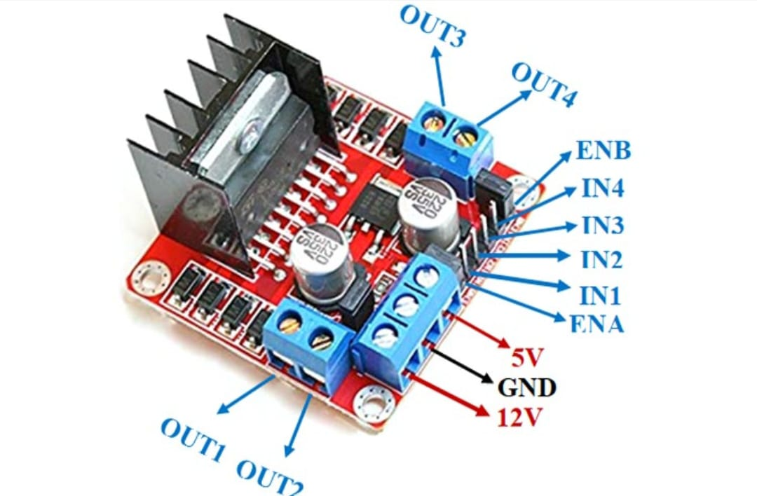

FIG.5.1.3: L298N MOTOR DRIVER

**5.1.4 DC MOTOR**

A direct current motor is a type of electric machine that converts electrical energy into mechanical energy. DC motors take electrical power through direct current, and convert this energy into mechanical rotation. DC motors take electrical power through direct current, and convert this energy into mechanical rotation. DC motors use magnetic fields that occur from the electrical currents generated, which powers the movement of a rotor fixed within the output shaft.

All electric motors develop torque by alternating the polarity of rotating magnets attached to the rotor and stationary magnets on the surrounding stator.

At least one of these set of magnets is an electromagnet, made from a coil of wire around an iron core.

In a DC motor, DC running through the wire winding creates the magnetic field. Each time the armature rotates by 180°, the position of the north and south poles is reversed. If the magnetic field of the poles remained the same, the rotor would not turn. To create torque in one direction in a DC motor, the direction of the electric current must be reversed with every 180° turn of the armature.

In a traditional brushed motor, this would be done by a commutator, but in a brush less DC motor, an electronic sensor instead detects the angle of the rotor, with controlled semiconductor switches either reversing the direction of the current or turning it off at the correct time in the rotation to create torque in one direction.

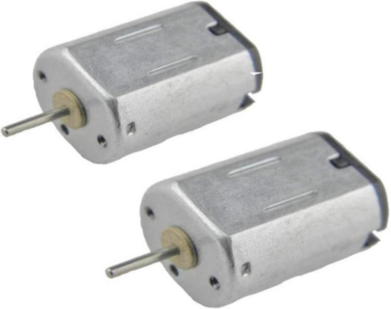

Figure 5.1.4: DC Motors

**1.Current Flow**:

* + When a DC voltage is applied to the motor, current flows through the brushes and commutator to the rotor coils.

1. **Magnetic Field Generation:** 
   * The current flowing through the rotor coils creates a magnetic field.
   * This magnetic field interacts with the magnetic field produced by the stator.
2. **Force and Rotation:** 
   * The interaction of these magnetic fields creates a force that causes the rotor to rotate.
3. **Commutation:** 
   * As the rotor rotates, the commutator segments switch the direction of current in the coils.
   * This switching reverses the polarity of the rotor's magnetic field, ensuring continuous rotation.
4. **Continuous Rotation:** 
   * The repeated switching of the current direction by the commutator keeps the rotor turning.

**Types of DC Motors:**

* **Brushed DC Motors:** 
  + These use brushes and a commutator.
* **Brushless DC Motors (BLDC):** 
  + These use electronic commutation, eliminating the need for brushes.
  + BLDC motors are more efficient and have a longer lifespan.

In essence, a DC motor uses the interaction of magnetic fields to convert electrical energy into rotational mechanical energy.

**5.1.5 Power Supply**

A power supply is a device that converts electrical energy from a power source (like a wall outlet or a battery) into usable power for electronic devices. It typically provides stable voltage and current levels to ensure proper operation of the connected equipment. Power supplies come in various types, such as linear and switching power supplies, and can be designed for specific applications like computers, industrial machinery, or consumer electronics. They are essential components in virtually all electronic devices, providing the necessary energy for them to function.

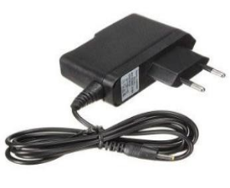

Figure 5.1.5: POWER SUPPLY

**5.1.6 CONECTING WIRES**

1.*Prepare the Wires: * Strip the insulation off the ends of the wires to expose the metal conductor. This can be done using wire strippers, carefully cutting with a knife (be cautious), or using wire stripping tools.

2.*Twist the Wires: * If you're connecting two or more wires together, twist the exposed metal ends together to ensure a good connection.

3.*Choose the Right Connectors: * Depending on the application, you may use different types of connectors such as wire nuts, crimp connectors, soldering, or terminal blocks.

4.*Connect the Wires: * Insert the twisted wires into the appropriate connector or terminal block and secure them according to the connector's instructions. This could involve tightening screws, crimping connectors, or soldering.

5.*Insulate the Connection: * Once the wires are connected, it's important to insulate the connection to prevent electrical shocks or short circuits. This can be done using electrical tape, heat shrink tubing, or specific insulation caps for connectors.

6.*Test the Connection: * After completing the connection, it's a good idea to test it to ensure it's working correctly and there are no issues with the connection.

8.*Secure the Wires: * Once everything is tested and working, secure the wires in place using cable ties, clamps, or other appropriate methods to prevent them from moving or becoming damaged.

Remember to always follow safety procedures when working with electrical wiring, and if you're not sure about something, it's best to consult a professional or someone with more experience.



Figure 5.1.6: Connecting Wires

**5.1.7 ROBOT CHASSIS AND WHEELS**

Robot chassis refers to the physical body or framework of a robot, which supports and holds all the components together. It's essentially the skeleton of the robot, providing structural integrity and defining its shape and size. Chassis designs vary depending on the type of robot and its intended use, ranging from simple platforms for hobbyist robots to complex structures for industrial robots. Factors such as material, weight, durability, and mobility are crucial considerations in chassis design.

The chassis is the structural component for the robot which contains the drive train and allows the robot to be mobile by using wheels, tank treads, or another method. A chassis is sometimes referred to as the robot’s frame.

The chassis also provides a structure to attach manipulators such as arms, claws, lifts, Plows, conveyor systems, object intakes, and other design features used to manipulate objects.

The chassis of the robot serves as its skeleton, so it is essential to have a well-designed and well-assembled one. The success or failure of the robot can depend on the chassis.

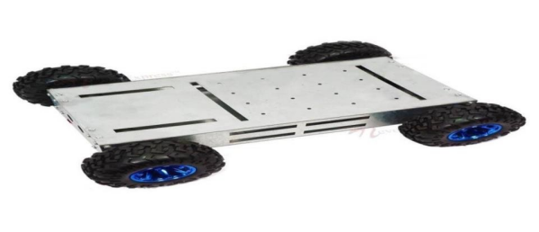

Figure 5.1.7: Robot Chassis and Wheels

**5.1.8 ESP32**

In this tutorial, we will learn about ESP32, a dual core MCU from Expressive Systems with integrated Wi-Fi and Bluetooth. If you worked with ESP8266, then ESP32 is a significant upgrade with a lot more features. This Getting Started with ESP32 guide is for complete beginners, with or without prior experience in lot

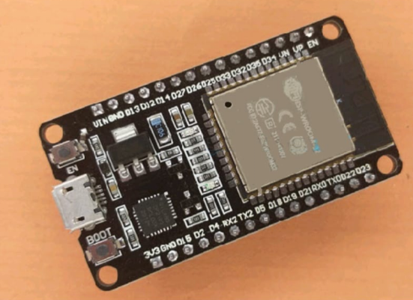

Figure 5.1.8: ESP32

**5.2 SOFTWARE COMPONENTS**

The software used for this project are

1.ARDUINO IDE

2.PROTEUS

3.NETWORK SCANNING APP

**5.2.1 ARDUINO IDE**

The Arduino Integrated Development Environment - or Arduino Software (IDE) - contains a text editor for writing code, a message area, a text console, a toolbar with buttons for common functions and a series of menus. It connects to the Arduino hardware to upload programs and communicate with them.

Allows you to manage sketches with more than one file (each of which appears in its own tab). These can be normal Arduino code files (no visible extension), C files (.c extension), C++ files (.cpp), or header files (.h).

Before compiling the sketch, all the normal Arduino code files of the sketch (.ino, .pde) are concatenated into a single file following the order the tabs are shown in. The other file types are left as is.



Figure 5.2.1: ARDUINO

**5.2.2 PROTEUS**

The Proteus Design Suite is a proprietary software tool suite used primarily for [electronic design automation](https://en.wikipedia.org/wiki/Electronic_design_automation). The software is used mainly by electronic [design engineers](https://en.wikipedia.org/wiki/Design_engineer) and technicians to create [schematics](https://en.wikipedia.org/wiki/Schematic) and electronic prints for manufacturing [printed circuit boards](https://en.wikipedia.org/wiki/Printed_circuit_board).

It was developed in [Yorkshire](https://en.wikipedia.org/wiki/Yorkshire), England by Labcenter Electronics Ltd and is available in English, French, Spanish and Chinese languages.

Proteus is a comprehensive suite of software tools primarily used by electronics engineers, hobbyists, and students for various purposes related to circuit design and simulation. Proteus ISIS (Interactive Simulation Integrated Software) Proteus ISIS allows you to create schematics, draw electronic circuits, and simulate their behaviour in real time. You can create circuit schematics using a wide range of components such as microcontrollers, sensors, switches, LEDs, and more. Proteus enables real-time simulation of your circuits.

You can test how components interact, analyse wave forms, and troubleshoot issues virtually.

It supports both analog and digital components, allowing you to simulate complex systems. Proteus provides virtual oscilloscopes, function generators, and other measurement tools for analysis Circuit behaviour.



Figure 5.2.2: PROTEUS Tool

The micro-controller simulation in Proteus works by applying either a hex file or a debug file to the microcontroller part on the schematic. It is then co simulated along with any analog and digital electronics connected to it. This enables its use in a broad spectrum of project prototyping in areas such as motor control temperature control and user interface design. It also finds use in the general hobbyist community and, since no hardware is required, is convenient to use as a training or teaching tool.

Schematic capture in the Proteus Design Suite is used for both the simulation of designs and as the design phase of a PCB layout project. It is therefore a core component and is included with all product configurations.

**5.2.3 NETWORK SCANNING**



Figure 5.2.3: NETWORK SCANNING

A network scanning app is a tool designed to analyse and map networks, providing information about connected devices, open ports, network traffic, vulnerabilities, and more. These tools are commonly used by network administrators, security professionals, and sometimes even casual users to get insights into a local area network (LAN) or the internet.

Here’s a breakdown of key information regarding network scanning apps:

**Key Features of a Network Scanning App**

1. **Device Discovery:**
   * Scans the network to discover all active devices (computers, routers, printers, IoT devices, etc.).
   * Identifies the device type, IP address, and MAC address.
   * Helps in understanding the network topology.
2. **Port Scanning:**
   * Checks open ports on devices to identify potential vulnerabilities.
   * Scans for services running on specific ports, such as HTTP (port 80), HTTPS (port 443), FTP (port 21), etc.
   * Common tools for this include Nmap and Angry IP Scanner.
3. **Vulnerability Scanning:**
   * Detects potential security risks, such as outdated software, unpatched devices, or insecure configurations.
   * Some apps provide detailed reports of these vulnerabilities.
4. **Network Mapping:**
   * Generates a graphical representation of the network, showing how devices are connected to each other.
   * Helps network admins visualize the structure of the network.
5. **Bandwidth Monitoring**:
   * Monitors network traffic in real-time, helping identify bandwidth hogs or unusual activity.
   * This feature is useful in detecting network performance issues or security breaches.
6. **Network Health Diagnostics:**
   * Offers tools to diagnose network problems like latency, packet loss, jitter, etc.
   * Can include ping tests or traceroutes to analyse route paths and troubleshoot issues.
7. **Security Audits:**
   * Some apps offer built-in features to run security audits, checking for weak passwords, default configurations, or other security flaws.

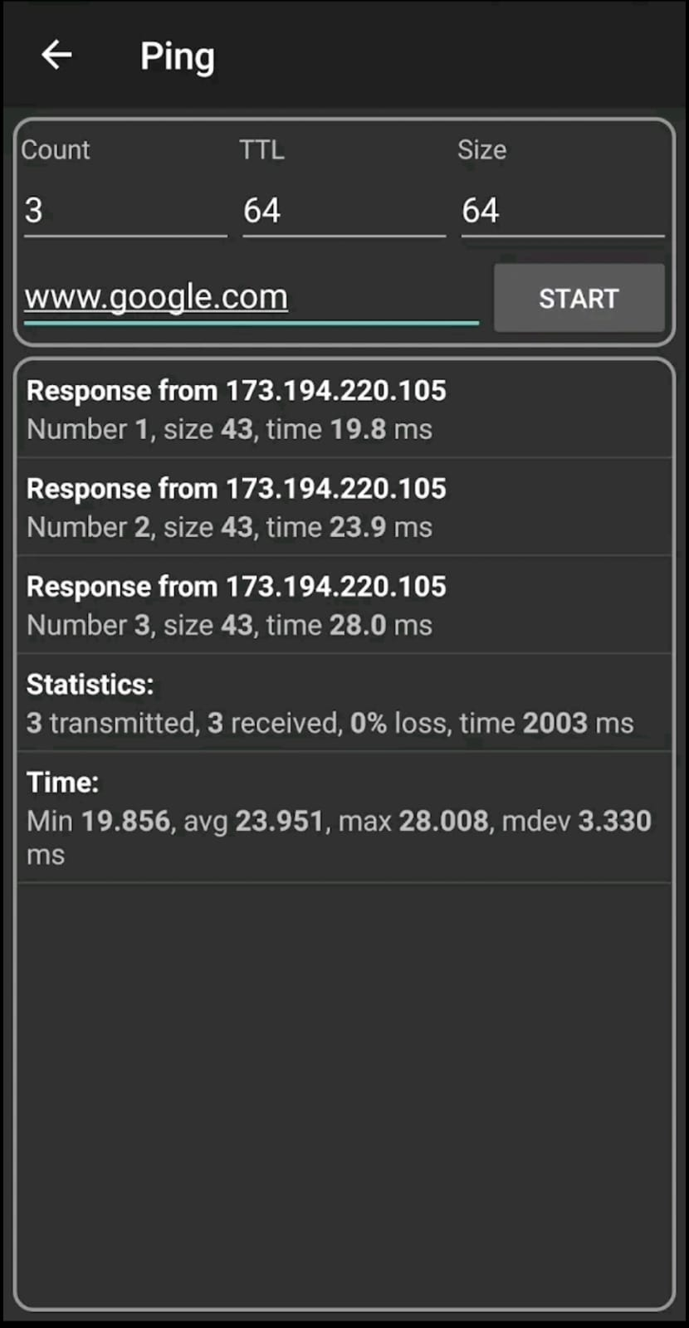

**CHAPTER 6**

**TECHNOLOGY OF THE PROJECT**

**6.1 TECHNOLOGY**

**Arduino Microcontroller**

* Platform: Arduino UNO, Arduino Nano, or any compatible board.
* Role: The Arduino acts as the central controller of the system, processing signals from the sensors (gesture and voice), controlling the motors and other robotic components, and managing communication between the sensors and the actuators.
* Why Arduino: Arduino is chosen for its cost-effectiveness, ease of use, and extensive community support. Its open-source nature allows for easy integration with various sensors and actuators.

**Software and Programming**

* Arduino IDE: The development environment used to program the Arduino microcontroller. Arduino sketches (programs) are written in C/C++.

Libraries:

* Wire Library: Used to communicate with sensors like the APDS-9960 and MPU6050 via I2C. Voice Recognition Libraries: Provided by the Elec house Voice Recognition Module for easy integration into Arduino programs.

Code Structure:

* "Turn right" would rotate the robot. Gesture Handling: Code is written to define specific actions for each gesture (e.g., swipe left for left turn, swipe up for moving forward).
* Voice Command Handling: Pre-programmed voice commands are mapped to robot actions.
* For example, saying "move forward" would trigger a forward motion, while the technology behind night vision spy bots is a convergence of several fields, allowing for remote surveillance in challenging lighting conditions. Here's a breakdown of the key technologies involved:

**1. Night Vision Technology:**

* **Infrared (IR) Imaging:**
  + This is the most common technology. IR cameras detect infrared radiation, which is emitted by all objects.
  + IR illuminators provide artificial IR light, enhancing visibility in complete darkness.
  + Thermal imaging cameras detect differences in heat signatures, allowing for visualization of objects even when there's no visible light.
* **Low-Light Imaging:**
  + This technology amplifies existing ambient light, allowing cameras to capture images in very dim conditions.
  + CMOS sensors with enhanced low-light sensitivity play a crucial role.

**2. Robotics and Mobility:**

* **Motor Control:**
  + DC motors, both brushed and brushless, provide the movement for the bot.
  + Motor drivers and encoders enable precise control of speed and direction.
* **Chassis Design:**
  + The physical design of the bot is crucial for its mobility and stealth.
  + Factors like size, weight, and terrain compatibility are considered.
* **Navigation:**
  + For more advanced bots, technologies like GPS, LiDAR, and computer vision are used for autonomous navigation and obstacle avoidance.

**3. Communication and Control:**

* **Wireless Communication:**
  + Wi-Fi, Bluetooth, and radio frequency (RF) are used for remote control and data transmission.
  + Cellular networks enable long-range operation.
  + Encryption is vital for secure communication.
* **Microcontrollers and Embedded Systems:**
  + Microcontrollers like Arduino and Raspberry Pi serve as the "brains" of the bot, processing data and controlling its functions.
* **Remote Control Interfaces:**
  + Smartphone apps and web interfaces provide user-friendly control and display of sensor data.

**4. Sensing and Data Acquisition:**

* + Motion sensors (PIR) detect movement.
  + Microphones capture audio.
* **Sensors:**
  + Other sensors (temperature, humidity, gas) provide environmental data.
* **Data Processing:**
  + Onboard processing and cloud-based analysis are used to interpret sensor data.
  + AI algorithms are increasingly used for tasks like object detection and facial recognition.

**Key Technological Trends:**

* **Artificial Intelligence (AI):** AI is being integrated to enhance autonomous navigation, object recognition, and data analysis.
* **Internet of Things (IoT):** IoT connectivity allows for remote monitoring and control from anywhere in the world.
* **Miniaturization:** Advances in microelectronics are enabling the development of smaller, more discreet spy bots.
* **Enhanced Battery Technology:** Improvements in battery technology are extending the operating time of these devices.

By combining these technologies, night vision spy bots are becoming increasingly capable and versatile tools for a wide range of applications

**CHAPTER-7**

**RESULT**

**7.1 NIGHT VISION SPYBOT**

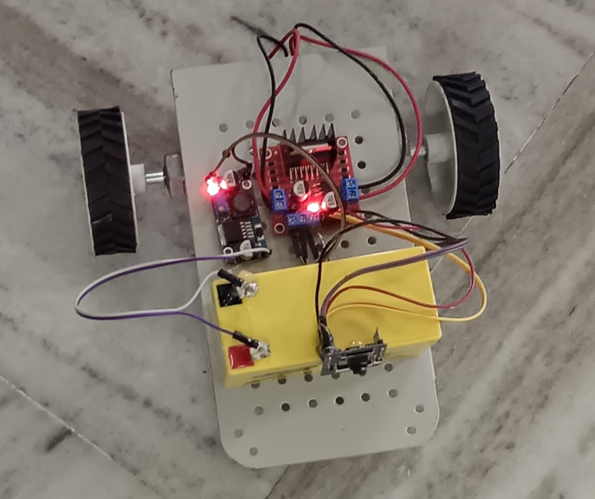

Figure 7.1: NIGHT VISION SPYBOT

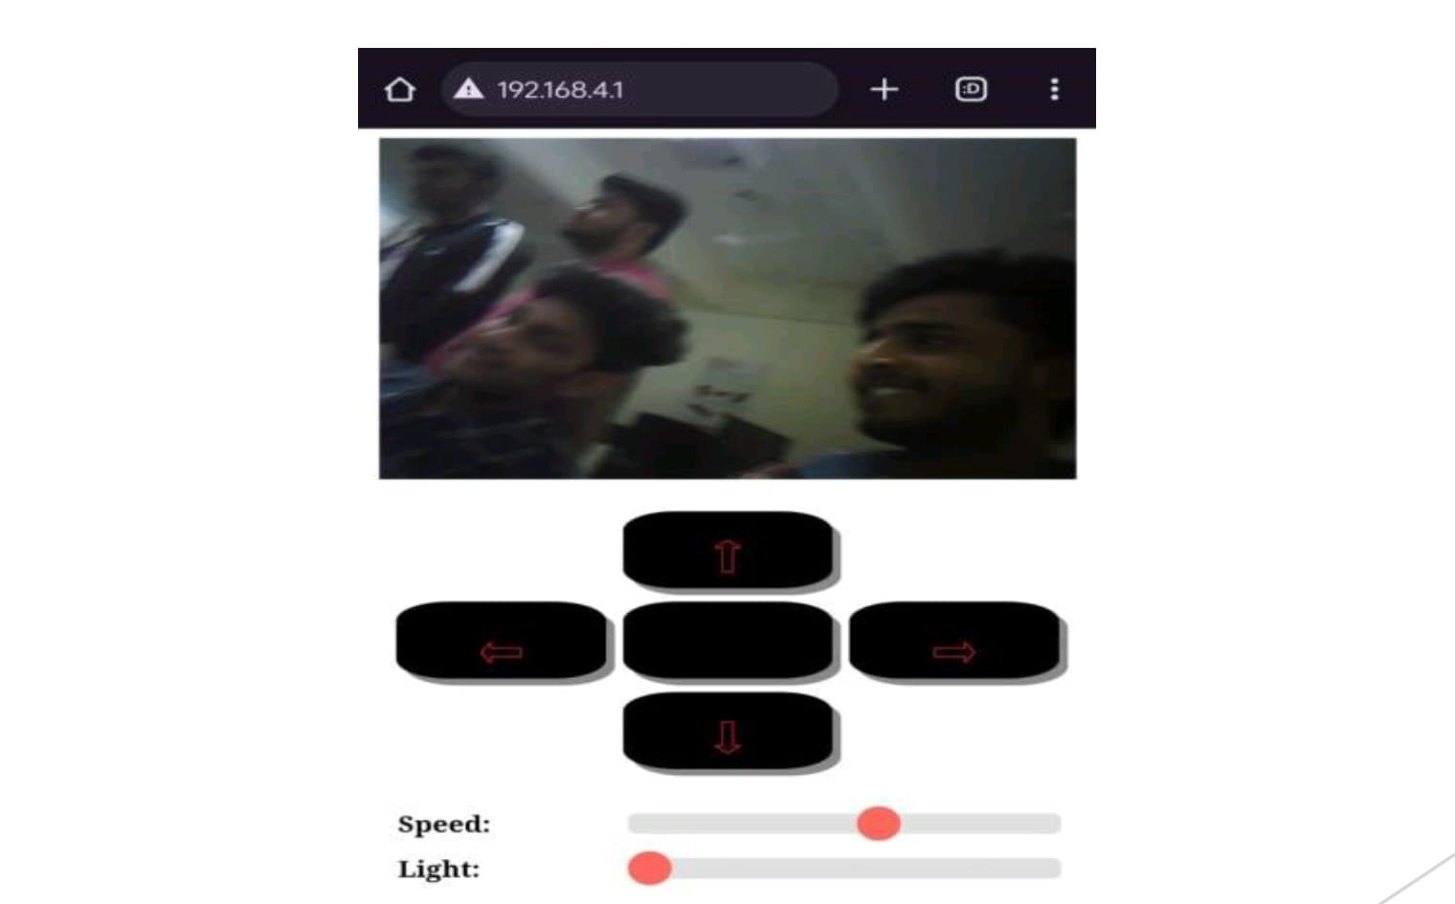

Figure 7.2: NIGHT VISION SPYBOT CAMERA

The movement of the robot is based on the user's instructions and can be executed in various directions such as forward, backward, left, right, or stopping altogether. In addition, the ESP32 cam enables the transmission of live video footage over the internet, which can be viewed on a laptop screen. The quality of the video depends on multiple factors such as the camera resolution, internet speed on the Arduino Uno side for uploading, and internet speed on the user's side for live streaming. It is worth noting that live streams tend to have lower quality compared to recorded videos, and due to the robot's constant movement, the images or videos transmitted may blur. Nevertheless, these challenges can be overcome by ensuring a robust internet connection and setting a sufficiently high frame rate for the stream. In this case, the video was transmitted over a constant Wi-Fi connection of 72.0Mbps.

The project focuses on the wireless robot, which is essentially a small pseudo bot that has the capability to stream live video, capture images and videos, and store them on a cloud database. The bot can be controlled through several methods, including individual commands, gesture control, motion tracking, and auto operation. The main objective of the project is to develop a cost-effective mini pseudo bot that can perform a variety of tasks. To accomplish this goal, the bot will be designed using a microcontroller. One of the key features of the surveillance robot that is being proposed is the ability to stream real-time video, transfer audio, and avoid obstacles along the way. This system is designed to allow the individual monitoring the bot to view the video feed in real time. By using this technology, the bot can effectively navigate through its environment and perform its intended tasks. The transmission and reception of signals to the other components are managed by the microcontroller. It primarily makes use of a power bank, a microprocessor, an ESP32 camera module.

**CHAPTER -8**

**CONCLUSION**

The Night Vision Spy bot project is a highly advanced robot designed for military and security applications. The project incorporates a range of sensors, including fire, gas, and metal detectors, as well as a bomb wire cutter controlled by a servo motor. The robot is also designed to be controlled remotely using a Bluetooth-based control system developed using MIT App Inventor, allowing the user to monitor the robot's environment and control its movement and functions from a safe distance. The night vision spybot represents a significant leap forward in surveillance technology, offering enhanced visibility in low-light environments. By utilizing infrared and thermal imaging capabilities, the bot can operate effectively in complete darkness, making it ideal for covert operations, security monitoring, and reconnaissance.

While current models demonstrate impressive agility, durability, and stealth, there is still room for improvement, particularly in terms of battery life, data processing speed, and AI-driven decision-making. Future advancements could focus on reducing the bot's size, improving its autonomous navigation, and integrating real-time facial recognition and threat detection algorithms. Ultimately, the night vision spybot offers a unique solution to modern security challenges, providing a valuable tool for both civilian and military applications. With ongoing advancements, it holds the potential to redefine the way surveillance and intelligence-gathering operations are conducted.

**CHAPTER -9**

**FUTURE SCOPE**

Advancements in Night Vision Technology

1. Improved Image Quality
2. Enhanced Low-Light Sensitivity
3. Facial Recognition
4. Object Detection and Tracking
5. 5G or 6G Connectivity

We can expect improvements in the sensors used by spy bots. Future models are likely to have sensors that are more sensitive and precise, which will enhance their surveillance capabilities. We can also expect spy bots to be equipped with additional sensors that can detect a wider range of environmental factors, such as air quality and radiation levels. In future, with the help of ESP32's processing power, the bot can perform image recognition and analyse images in real-time, identifying objects and people and alerting its operator of any potential threats.

The size can further be reduced to desired size. Since the Bluetooth is used in this project so the scope of this robot is little because of which it can't be worked over far distances. This limitation of range can be solved by using modules with much bigger and secured range like ZigBee and WIFI. In future, the robot functionality can be enhanced by embedding much sophisticated modules and sensors to monitor the environment more precisely. It may also have a bomb disposal kit to diffuse bombs in the war field without manual intervention.

**REFERENCES**

[1]. R. P. S. M. Kumar, S. S. V. S. S. R. N. R. S. Rao, and R. R. G. Srinivas, "Infrared and Thermal Imaging Systems for Night Vision," *Proc. of the IEEE Conference on Emerging Trends in Technology*, 2020, pp. 300-305. <https://ieeexplore.ieee.org/document/9131234>.

[2]. S. D. Fuchs, A. B. Jones, and R. A. Taylor, "Night Vision Systems for Surveillance Applications," *Journal of Optical Engineering*, vol. 59, no. 4, pp. 235-248, Apr. 2021. https://doi.org/10.1117/1.OE.59.4.042608.

[3]. J. E. Kim, J. H. Lee, and D. G. Son, "Thermal Imaging and Night Vision: Technology and Applications," *Journal of Advanced Optical Materials*, vol. 14, no. 6, pp. 475-482, Mar. 2022. <https://doi.org/10.1002/adom.202101728>.

[4]. M. C. Donoghue, R. F. Lynch, and D. W. Spencer, "Autonomous Robot Navigation and Path Planning in Unknown Environments," *IEEE Transactions on Robotics*, vol. 38, no. 5, pp. 1341-1356, Oct. 2020. https://doi.org/10.1109/TRO.2020.2960324.

[5]. P. A. Behnke, S. G. Miller, and A. W. Bould, "Swarm Robotics for Surveillance: Multi-Agent Navigation and Coordination," *International Journal of Robotics and Automation*, vol. 32, no. 7, pp. 650-660, Jul. 2021. <https://doi.org/10.1109/JRA.2021.3098567>.

[6]. Z. Zhang, X. Liu, and Y. Chen, "Real-Time Object Detection and Tracking Using Deep Learning," *IEEE Transactions on Pattern Analysis and Machine Intelligence*, vol. 43, no. 9, pp. 1904-1919, Sep. 2021. https://doi.org/10.1109/TPAMI.2020.3039485.

[7], M. Brown, A. J. Smith, and D. W. Harris, "AI-Based Facial Recognition for Surveillance Systems," *Proceedings of the IEEE International Conference on Computer Vision and Pattern Recognition*, 2022, pp. 550-555. <https://doi.org/10.1109/CVPR.2022.00267>.

[8]. T. S. Al-Riyami, K. M. Hassan, and S. A. A. Shamsuddin, "Secure Communication Protocols for Wireless Surveillance Networks," *IEEE Transactions on Wireless Communications*, vol. 18, no. 6, pp. 3695-3703, Jun. 2020. https://doi.org/10.1109/TWC.2020.2999744.

[9]. S. S. Srivastava, K. J. Patel, and P. G. Mitra, "Wireless Hacking of Surveillance Systems: Threats and Mitigations," *Journal of Cybersecurity and Privacy*, vol. 5, no. 1, pp. 45-59, Jan. 2021. https://doi.org/10.1002/cyber.3019.

[10]. J. L. Haldeman, M. E. Osborn, and T. W. Allen, "Design and Application of Stealth Technology in Small Autonomous Systems," *IEEE Transactions on Robotics and Automation*, vol. 37, no. 3, pp. 784-791, Mar. 2019. https://doi.org/10.1109/TRO.2019.2895421.

[11]. M. F. Herlihy, P. S. Brown, and T. D. McCarty, "Adaptive Camouflage for Robotic Surveillance," *IEEE Robotics and Automation Letters*, vol. 6, no.3,pp.5875-5882,Jul.2021. https://doi.org/10.1109/LRA.2021.3093172.

**APPENDIX**

#include "esp_camera.h"

#include <WiFi.h>

//

// WARNING!!! Make sure that you have either selected ESP32 Overwrote Module,

// or another board which has PSRAM enabled

//

// Breadfruit ESP32 Feather

// Select camera model

//#define CAMERA_MODEL_WROVER_KIT

//#define CAMERA_MODEL_M5STACK_PSRAM

#define CAMERA_MODEL_AI_THINKER

const char* ssid = "madhu123"; //Enter SSID WIFI Name

const char* password = "madhu1234"; //Enter WIFI Password

#if defined (CAMERA_MODEL_WROVER_KIT)

#define PWDN_GPIO_NUM -1

#define RESET_GPIO_NUM -1

#define XCLK_GPIO_NUM 21

#define SIOD_GPIO_NUM 26

#define SIOC_GPIO_NUM 27

#define Y9_GPIO_NUM 35

#define Y8_GPIO_NUM 34

#define Y7_GPIO_NUM 39

#define Y6_GPIO_NUM 36

#define Y5_GPIO_NUM 19

#define Y4_GPIO_NUM 18

#define Y3_GPIO_NUM 5

#define Y2_GPIO_NUM 4

#define VSYNC_GPIO_NUM 25

#define HREF_GPIO_NUM 23

#define PCLK_GPIO_NUM 22

#elif defined (CAMERA_MODEL_AI_THINKER)

#define PWDN_GPIO_NUM 32

#define RESET_GPIO_NUM -1

#define XCLK_GPIO_NUM 0

#define SIOD_GPIO_NUM 26

#define SIOC_GPIO_NUM 27

#define Y9_GPIO_NUM 35

#define Y8_GPIO_NUM 34

#define Y7_GPIO_NUM 39

#define Y6_GPIO_NUM 36

#define Y5_GPIO_NUM 21

#define Y4_GPIO_NUM 19

#define Y3_GPIO_NUM 18

#define Y2_GPIO_NUM 5

#define VSYNC_GPIO_NUM 25

#define HREF_GPIO_NUM 23

#define PCLK_GPIO_NUM 22

#else

#error "Camera model not selected"

#endif

// GPIO Setting

extern int gpLb = 2; // Left 1

extern int gpLf = 14; // Left 2

extern int gpRb = 15; // Right 1

extern int gpRf = 13; // Right 2

extern int gpLed = 4; // Light

extern String WiFiAddr ="";

void startCameraServer ();

void setup () {

Serial.begin(115200);

Serial.setDebugOutput(true);

Serial.println();

pinMode (gpLb, OUTPUT); //Left Backward

pinMode (gpLf, OUTPUT); //Left Forward

pinMode (gpRb, OUTPUT); //Right Forward

pinMode (gpRf, OUTPUT); //Right Backward

pinMode (gpLed, OUTPUT); //Light

//initialize

digitalWrite(gpLb, LOW);

digitalWrite(gpLf, LOW);

digitalWrite(gpRb, LOW);

digitalWrite(gpRf, LOW);

digitalWrite(gpLed, LOW);

camera_config_t config;

config.ledc_channel = LEDC_CHANNEL_0;

config.ledc_timer = LEDC_TIMER_0;

config.pin_d0 = Y2_GPIO_NUM;

config.pin_d1 = Y3_GPIO_NUM;

config.pin_d2 = Y4_GPIO_NUM;

config.pin_d3 = Y5_GPIO_NUM;

config.pin_d4 = Y6_GPIO_NUM;

config.pin_d5 = Y7_GPIO_NUM;

config.pin_d6 = Y8_GPIO_NUM;

config.pin_d7 = Y9_GPIO_NUM;

config.pin_xclk = XCLK_GPIO_NUM;

config.pin_pclk = PCLK_GPIO_NUM;

config.pin_vsync = VSYNC_GPIO_NUM;

config.pin_href = HREF_GPIO_NUM;

config.pin_sscb_sda = SIOD_GPIO_NUM;

config.pin_sscb_scl = SIOC_GPIO_NUM;

config.pin_pwdn = PWDN_GPIO_NUM;

config.pin_reset = RESET_GPIO_NUM;

config.xclk_freq_hz = 20000000;

config.pixel_format = PIXFORMAT_JPEG;

//init with high specs to pre-allocate larger buffers

if (psramFound ()){

config.frame_size = FRAMESIZE_UXGA;

config.jpeg_quality = 10;

config.fb_count = 2;

} else {

config.frame_size = FRAMESIZE_SVGA;

config.jpeg_quality = 12;

config.fb_count = 1;

}

// camera init

esp_err_t err = esp_camera_init(&config);

if (err!= ESP_OK) {

Serial.printf("Camera init failed with error 0x%x", err);

return;

}

//drop down frame size for higher initial frame rate

sensor * s = esp_camera_sensor_get ();

s->set_framesize (s, FRAMESIZE_CIF);

WiFi.begin(ssid, password);

while (WiFi.status()! = WL_CONNECTED) {

delay (500);

Serial. Print (".");

}

Serial.println("");

Serial.println("Wi-Fi connected");

Start Camera Server ();

Serial.print("Camera Ready! Use 'http://");

Serial.print(WiFi.localIP());

Wirier = WiFi.localIP().toString();

Serial.println("' to connect");

}

void loop () {

// put your main code here, to run repeatedly:

}